Software Requirements Specification

for

E-Commerce Platform

Version 1.1

Supervised By

Dr. Suman Ahmmed

Associate Professor, Dept. of CSE, UIU

Group Members Name

Nusrat Jahan Sarna 0122410015

Farzana Ahmed Rithen 0122410051

Md. Nazmuz Sakib 0122410053

Mohammad Shohal Bhuiyan 0122320020

Table of Contents

Table of Contents

Software Requirements Specification 3

1. Introduction 3

2. Objective 4

3. Methodology 4

4. Specification Analysis 5

4.1 Benchmark Table Analysis 5

4.2 Related research papers 7

4.4 User Feedback 9

5. Features List Fixation 12

5.1 Functional Feature List 12

5.2 Non-Functional Feature List 14

5.3 Novelty 17

6. SWOT Analysis 17

7. A conventional Cash Flow Diagram for An E-Commerce Platform: 20

8. UML Diagram 22

8.1 Use Case Diagram 22

8.1.1 Use Case Description 23

8.2 Activity Diagram 24

References 26

# **Software Requirements Specification**

## **1.** **Introduction**

E-commerce, or electronic commerce, refers to the buying and selling of goods or services over the Internet. It has revolutionized the way businesses operate and consumers shop by providing convenient, accessible, and often personalized experiences. E-commerce encompasses various models, including online retail stores, auction sites, digital marketplaces, and subscription-based services. With the widespread adoption of mobile devices and secure online payment systems, e-commerce has seen exponential growth globally, offering businesses opportunities to reach broader audiences and consumers the flexibility to shop anytime, anywhere.

In the ever-evolving landscape of e-commerce, one of the fundamental challenges lies in the diverse categorization systems utilized across different platforms. Each software solution offers its unique set of categories, often resulting in mismatches with the specific needs and expectations of users. Recognizing this critical issue, our team embarked on a mission to create a comprehensive e-commerce platform that addresses the category conundrum head-on.

Beyond the realm of categories, we understand the importance of seamlessly integrating essential features that form the backbone of any successful e-commerce venture. From the ubiquitous "Add to Cart" functionality to real-time customer support through live chat, our platform endeavors to streamline the shopping journey, ensuring maximum convenience and satisfaction for all stakeholders involved. Moreover, we recognize the significance of linguistic diversity in today's global marketplace. With multilingual support embedded at its core, our platform empowers businesses to engage with customers across linguistic barriers, fostering inclusivity and accessibility on a global scale.

Central to our vision is the creation of a user interface (UI) that not only addresses existing pain points but also anticipates and mitigates future challenges. Through a meticulous design process informed by user feedback and industry best practices, we strive to deliver an interface that is both intuitive and adaptable, enabling seamless navigation and empowering users to focus on what truly matters: their products and their customers.

In essence, our e-commerce platform represents a paradigm shift in the way online businesses approach categorization, functionality, and user experience. By prioritizing flexibility, accessibility, and innovation, we aspire to redefine the standards of excellence in the digital marketplace, empowering businesses of all sizes to thrive and succeed in an increasingly competitive landscape.

## **Objective**

To develop a comprehensive Software Requirements Specification (SRS) report for an advanced e Commerce platform. This SRS document aims to provide a detailed and systematic outline of the functional and non-functional requirements, features, and constraints of the proposed e-Commerce system.

The objective of this Software Requirements Specification (SRS) document is to provide a comprehensive understanding of the functional and non-functional requirements for the development of an E-Commerce platform. This document aims to establish a clear and concise description of the system's features, functionalities, and constraints, serving as a blueprint for developers, designers, and stakeholders involved in the project.

## **Methodology**

The Software Requirements Specification (SRS) document aims to address usability issues commonly encountered in e-commerce platforms, such as difficulty in finding products due to poor design and limited categorization options. This document proposes solutions to enhance user experience by introducing four main categories and improving UI design. Additionally, it serves as a guide for developers to implement these improvements effectively. Figure 1 illustrates the breakdown of activities involved in creating the SRS document, including UML Diagrams, UI design enhancements, and Research Paper review.

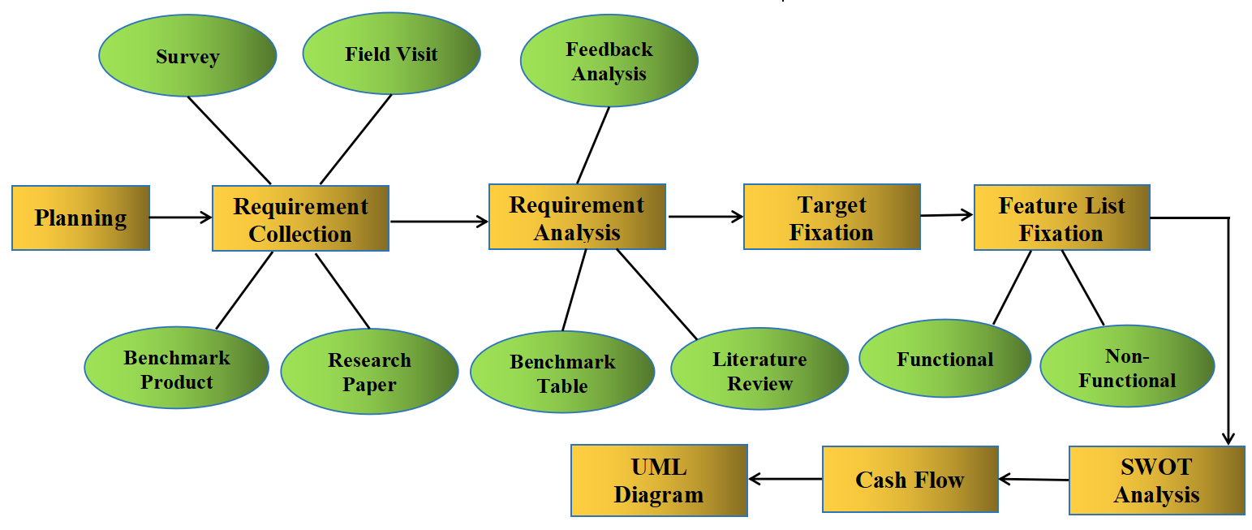

**Figure 1 Work Breakdown Process**

## **Specification Analysis**

In this section, we describe ‘Benchmark Table Analysis’, ‘Related Research Papers’, ‘Feasibility Analysis’ and ‘User Feedback’.

### **4.1 Benchmark Table Analysis**

Based on the findings outlined in Table 1, it has been observed that various national and international software solutions offer a diverse range of features tailored to the e-commerce domain. These features encompass functionalities such as "Add to Cart," "Navigation Bar," "Category by Trending Product," "Category by Product Generation," "Category by Price Range," "Category by Compare Product," "Payment Gateway," "Search," "Location," "Offer," "Language," "Live Chat," "Review," and "Return Policy."

Among the software investigated, it was identified that "Navigation Bar," "Add to Cart," "Payment," "Search," and "Offer" constitute common features across the platforms under scrutiny. Specifically, Evaly, Amazon, and Chaldal distinguish themselves by offering the "Category by Trending" feature. However, notable absences were observed regarding the provision of "Category by Price Range" and "Category by Compare Product" within any of the examined software solutions. Consequently, these functionalities have been incorporated into our software offering to enhance user experience comprehensively.

Furthermore, while both Evaly and Amazon include the "Category by Product Generation" feature, it is not present in other surveyed software. As part of our commitment to delivering a robust e-commerce platform, we have ensured the inclusion of this feature in our solution, thus augmenting the array of tools available to users for efficient product discovery.

In summary, our software distinguishes itself by amalgamating all categories present in the examined platforms, thereby facilitating enhanced product search and discovery capabilities for users. By consolidating these features and addressing existing gaps, our platform endeavors to provide a seamless and enriching e-commerce experience, ultimately empowering users to locate desired products with ease and efficiency.

|  |  |  |  |  |  |  |  |
| --- | --- | --- | --- | --- | --- | --- | --- |
| **Feature \ Software** | **Daraz [7]** | **Evaly [8]** | **Amazon [9]** | **Rokomari [10]** | **Chaldal [11]** | **Bikroy.com [12]** | **Proposed Product** |
| Add to Cart | Yes | Yes | Yes | Yes | Yes | Yes | Yes |
| Navigation Bar | Yes | Yes | Yes | Yes | Yes | Yes | Yes |
| Category by Trending Product | No | Yes | Yes | No | Yes | No | Yes |
| Category by Product Generation | No | Yes | Yes | No | No | No | Yes |
| Category by Price Range | No | No | No | No | No | No | Yes |
| Category by Compare Product | No | No | No | No | No | No | Yes |
| Payment Gateway | Yes | Yes | Yes | Yes | Yes | Yes | Yes |
| Search | Yes | Yes | Yes | Yes | Yes | Yes | Yes |
| Location | Yes | No | Yes | No | No | No | Yes |
| Offer | Yes | Yes | Yes | Yes | Yes | Yes | Yes |
| Language | Yes | No | Yes | No | Yes | Yes | Yes |
| Live Chat | Yes | No | Yes | Yes | Yes | Yes | Yes |
| Review | Yes | No | Yes | Yes | Yes | Yes | Yes |
| Return Policy | Yes | No | Yes | No | No | No | Yes |

**Table 1: Benchmark product Comparison**

### **4.2 Related research papers**

Octavian Dospinescu *et al.,* (2021) conducted a study on the determinants of e-commerce satisfaction in a specific region(Romania and Moldova). In the study, the authors tried to depict the features of an e-commerce platform which determine the level of satisfaction for an e-commerce platform.Some of the highlighted features are a periodic notification system, control over the delivery process by the customers, order canceling system, live chat option, price comparison among same category products, diversified e-payment, security of the platform, and sales services.In the conclusion the authors wanted to depict that the determinants of e-commerce satisfaction may vary from region to region, that's why there are still chances to enhance the performance of an e-commerce platform by adding some extra-ordinary features on the platform.

Muhammad Fadhil Dzulfikar *et al.,* (2018)addressed the current issues of the business-to-customers type e-commerce platform and proposed a paper on personalization features of the platform.They had enlisted a sort of features that could be the solution to the issues they had diagnosed.The features are navigation tools, aesthetic appearance, customization layout, multiple language options, promotions of the products, save option for recently browsed items, product search, social based recommendation, review, reward for the customers, recommendation of the product according to price based on the previous record of a customer, discount, product searching based on location.Besides all of these, it can be understood that the relational personalization will be different according to the regional surroundings, so that can be a scope for future modification.

Ghada Taher (2021)mentioned the limitations and advantages of e-commerce, buying 24/7 all year long, time-saving option for the customer, comparison between multiple same-category products, containing adequate information about the product, providing multiple options for the customers in the context of price these are the advantages which are highlighted by the author.Besides the advantages, disadvantages like lack of personal touch with the customers, delay in the delivery, security issues, and damage during the delivery should be considered.the advantages and the disadvantages could be a clue for the better performance of an e-commerce platform and lead towards future

S. A. Bhat *et al.,* (2016) depicted some mandatory elements for an e-commerce platform. The authors highlighted multiple payment gateways, analysis of the customer's history, the importance of social media for the promotion of the platform and the products,24/7 call center, consistency of the design of the platform, location-based services, product variety, shipment option, clear and realistic terms and conditions and most importantly the privacy.From all these, it can be easily assumed the features of an e-commerce platform.

Elham Mohammed Thabit AbdAlameer (2014) proposed a model for an e-commerce website.In that model author proposed aesthetic display of the content, product search option by image, customer rewards, discounts, online payment option, product identity by ID, advertisement of the website, promotions of products, and security management as features of the website.

Vipin Jain *et al.,* (2021) reviewed some fundamental facilitators of e-commerce including the Internet, multiple payment gateway, analytic features for the business owner, social media interaction with e-commerce, autonomous vehicles for the delivery option, security, and highlighted some advantages and challenges associated with the e-commerce.

**4.3 Feasibility Analysis**

Feasibility analysis is like a detective's investigation into a business idea's potential. It digs into whether a plan is doable, financially sound, and worthwhile. It's the roadmap that tells you if your dreams can become reality or if they're better left on the drawing board. From market research to crunching numbers, feasibility analysis is the Sherlock Holmes of business strategy, uncovering clues to success or warning signs of failure.

**Technical Analysis:** We have identified certain potential risks, such as requirement interconnections and time management issues. To mitigate these concerns, we have implemented specific strategies. Firstly, we have established a documentation process for client requirements. This entails creating comprehensive documentation that is reviewed and approved by the client. Subsequently, the client provides a final revision and signs off on the documentation, serving as evidence to prevent any subsequent denial of agreed-upon requirements. Additionally, we have imposed strict deadlines for the developer team, ensuring that the completion date is set well in advance of the final release, typically at least 2 to 3 days prior.

**Economic Analysis:** Here, it is imperative to conduct a cost-benefit analysis of our system. Given that we utilize this site for business purposes, assessing the costs and benefits associated with its operation is essential.

**Observer Analysis:** We observe user preferences regarding website types and prioritize market trends when designing our website. In the realm of e-commerce, our platform stands out as particularly popular worldwide in today's era, given the universal desire to optimize time efficiency. Therefore, it represents a promising project for the current period.

**Behavioral Analysis:** Ensuring the security of user information, accurate data collection, and maintaining reliability and flexibility in our services are integral aspects of our operations.

### **4.4 User Feedback**

We conduct our user feedback in 2 way. Such as:

1. Survey
2. Industry Visit

Now we describe this feedback which we gather by survey and industry visit.

1. **Survey:** We add some picture of our survey report.

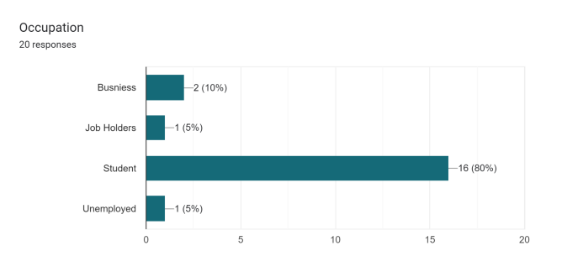 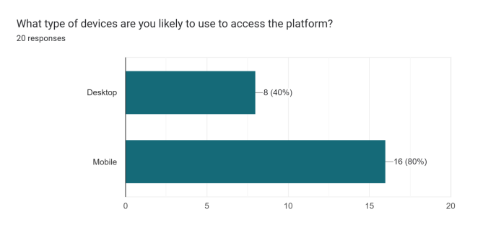

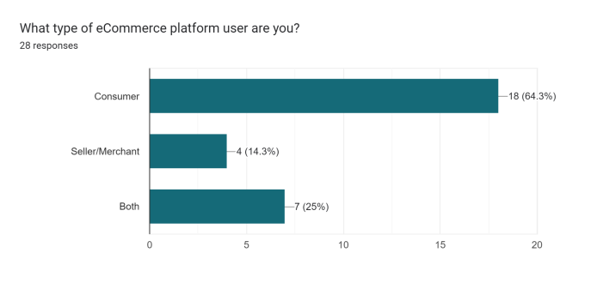 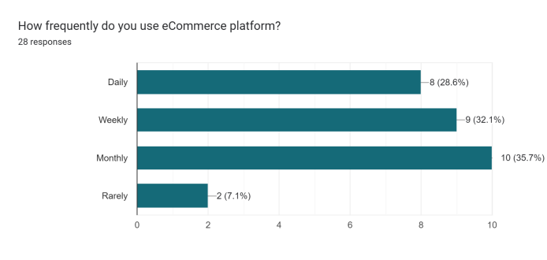

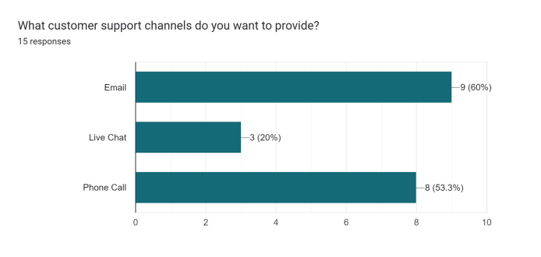 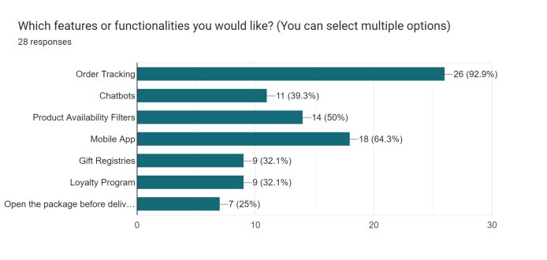

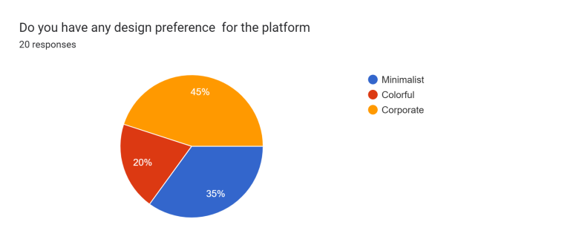 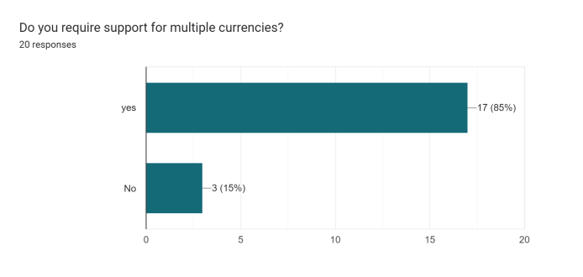

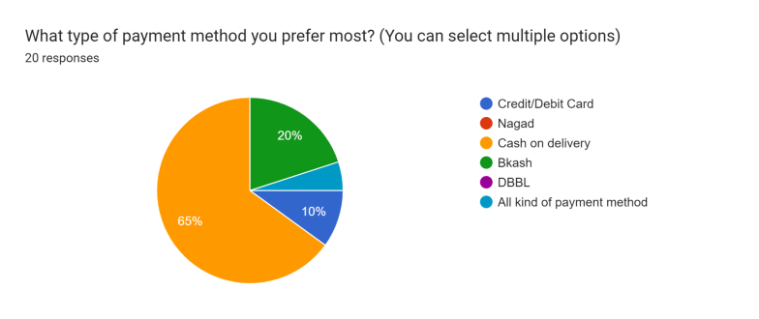 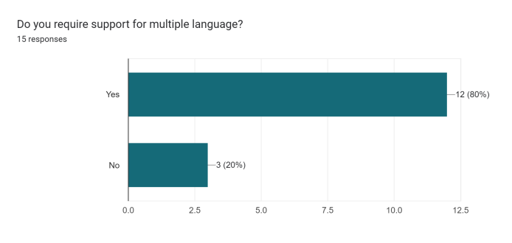

**Are there any specific features or functionalities you would like to see added to a new E-Commerce platform?**

* Genuine images of that product & brief descriptions & functionality/How it work.
* Bug fixing
* 1. Product review from a customer. 2. The product searching system. should be efficient. 3. practical image of the product as well as the edited one.
* No
* Advanced AI chatbot may be integrated for quick chat.
* I have no idea
* Chat system with seller
* Merge all Categories which can help to find out the exact product.
* payment, return and refund methods are too much helpful for a consumer.
* no
* Yes, I want to have the e-commerce platform support in rural areas
* Price shown
* Please merge all categories for filtering my exact product.
* Product comparison function

**ii) Industry Visit**

We conducted an industry visit to BOHU, a furniture-based company, with the objective of gathering insights into their e-commerce operations. This involved engaging in structured interview sessions with their employees to obtain comprehensive knowledge regarding their e-commerce platform.

What payment method do customers prefer?

* + Customers predominantly favor cash on delivery as their preferred payment method. Additionally, they have the option to make payments via Bkash. Conversely, for significant orders, we typically secure a partial advance payment. Mr. Tamim elaborated on this point.

Is it manageable as a controller when an order is received?

* + Mr. Tamim affirmed that managing orders is relatively straightforward, attributing the ease to the user-friendly design of their administrative panel interface.

Have you encountered any complaints from customers regarding features on your e-commerce site?

* + Working at a furniture company, he encountered a customer concern regarding the representation of wooden furniture types on their website. The customer advised that although various wood types were available, only one color was displayed on the site, making it challenging to discern and evaluate the other available colors. Following this feedback, Mr. Tamim stated that they promptly addressed this issue by updating the website.

Do your international customers prefer to communicate in their native language?

* + No, we haven't encountered such an issue. Despite catering to a diverse clientele, including embassy clients, we have consistently found that they do not express a preference for communicating in their native languages. Instead, they predominantly communicate with us in English.

Is the user interface design of your website considered user-friendly from the client's perspective?

* + Certainly. We have consistently received positive feedback from our customers, indicating satisfaction with the user-friendliness of our website's client-side UI design.

## **Features List Fixation**

In this section, we describe ‘Functional Feature List’, ‘Non-Functional Feature List’, and ‘Novelty’.

### **5.1 Functional Feature List**

The essential abilities that directly support an e-commerce website's main operation are known as functional features. These are expressed as the expected output and the input to be supplied to the system.

1. Navigation Bar: A menu at the top of the website that provides multiple options and links to different sections. It typically includes categories, payment, sign-in/sign-out, and more.
2. Add to Cart: A clicking option allows users to add items to their virtual shopping cart. This enables customers to gather products for eventual purchase.
3. Category: This helps users to get products that are organized into different for easy browsing. Users can explore specific sections based on their interests.
4. Category by Trending Product: Highlighted products that are currently popular or trending among other shoppers. This section often showcases items with high demand or special promotions to the customers. Users will be suggested which products have sold more from the website.
5. Category by Product Price Range: This feature provides a predefined price range option for quick filtering choices for users. Specific values to set the minimum and maximum price they are willing to pay for a product. Once users set their desired price range, the website dynamically filters and displays products that fall within the specified price limits. This helps users focus on products that align with their budget.
6. Category by Compare Products: This feature is particularly useful when users are considering several options and want to evaluate their specifications, features, and pricing in a comprehensive manner. Users can initiate the comparison process by selecting the "Compare" option on the product listings or product detail pages. The comparison page displays the selected products side by side, with each product assigned.
7. Category by Product Generations: For products with different versions (e.g. old version & premium version) or releases, this feature allows users to select and view products from specific generations or models. Each product listing typically includes information about its generation or model. Products with multiple generations or versions are organized and displayed in a structured manner on the website.
8. Payment Gateway: The method by which customers can securely pay for their purchases. It includes options like credit/debit cards, mobile payments, and other online payment methods.
9. Search: A search bar that enables users to quickly find specific products, brands, or categories by entering keywords.
10. Location: Users may set their location or input their address for accurate delivery estimates and location-specific deals.
11. Language: Allows users to select their preferred language for browsing the website. This enhances accessibility for a diverse user base.
12. Live Chat: Real-time chat support that enables users to communicate with customer service representatives or support agents for assistance.
13. Customer Review: Feedback and ratings provided by customers who have purchased and used a particular product. Reviews help other shoppers make informed decisions.
14. Vouchers & Offers: Special discounts, promotions, or voucher codes that users can apply during the checkout process to avail themselves of additional benefits.
15. Return Policy: It serves as a set of guidelines that provide transparency and assurance to customers regarding the process of returning items they are dissatisfied with or encounter issues with. This option is available to customers upon successful return. This may include a refund, store credit, or the option to receive a replacement product.

These functional features collectively contribute to creating a comprehensive and user-friendly e-commerce website.

### **5.2 Non-Functional Feature List**

Here we focus on the Non-functional requirements for the mentioned features in an e-commerce website focusing on aspects such as performance, security, usability, and scalability.

1. **Navigation Bar:**

**Performance:**

Response Time: The navigation bar should have low latency, ensuring quick loading and responsiveness.

**Usability:**

Consistency: The navigation bar design should be consistent across different pages for a seamless user experience.

**ii) Add to Cart:**

**Performance:**

Response Time: Adding items to the cart should have minimal delay.

**Security:**

Data Encryption: Ensure that sensitive data, such as the user's shopping cart contents, is encrypted during transmission.

**iii) Category:**

**Performance:**

Loading Time: Category pages should load quickly to provide an efficient browsing experience.

**Usability:**

Accessibility: Ensure that category names are clear and accessible, catering to users with disabilities.

**iv) Trending Product:**

**Performance:**

Real-time Updates: The trending product section should be dynamically updated to reflect the current trends.

**Usability:**

Visual Presentation: Present trending products with high-quality images for an engaging user experience.

**v) Price Range:**

**Performance:**

Filtering Speed: The price range filter should provide quick results without causing delays.

**Usability:**

Clear Interface: Ensure a user-friendly interface for setting and adjusting the price range.

**vi) Compare Product:**

**Performance:**

Comparison Load Time: The comparison page should load quickly, even when multiple products are being compared.

**Security:**

Secure Data Handling: Ensure that the compared product details are handled securely, especially when involving user accounts.

**vii) Product Generations:**

**Performance:**

Load Time: Displaying information for different product generations should not significantly impact page load times.

**Usability:**

Clear Navigation: Users should easily switch between product generations with clear navigation options.

**viii) Payment Gateway:**

**Security:**

Secure Transactions: Ensure secure data transmission and storage of payment information.

Compliance: Adhere to industry standards and regulatory requirements for online payment processing.

**ix) Search:**

**Performance:**

Search Speed: The search feature should provide quick and relevant results.

**Usability:**

Auto-suggestions: Implement auto-suggestions to enhance the search experience.

**x) Location:**

**Usability:**

User-Friendly Interface: Ensure a clear and intuitive interface for users to set and update their location preferences.

**xi) Language:**

**Usability:**

Multilingual Support: The website should support multiple languages, enhancing accessibility for a diverse user base.

**xii) Live Chat:**

**Performance:**

Real-time Interaction: Live chat should offer real-time communication without noticeable delays.

**Security:**

Secure Communication: Ensure secure communication channels for live chat interactions.

**xiii) Customer Review:**

**Usability:**

User-Friendly Interface: Provide an intuitive interface for users to submit and read product reviews.

Moderation: Implement moderation mechanisms to ensure the quality and authenticity of reviews.

**xiv) Vouchers & Offers:**

**Performance:**

Redemption Speed: Applying vouchers or offers should not cause delays during the checkout process.

**Security:**

Secure Voucher Handling: Ensure secure handling of voucher codes to prevent misuse.

**xv) Return Policy:**

**Usability:**

Clear Communication: The return policy should be communicated to users during the checkout process.

**Compliance:**

Legal Compliance: Ensure that the return policy adheres to relevant laws and regulations.

These non-functional requirements help to ensure that the mentioned features contribute to an e-commerce website's overall performance, security, and user satisfaction. The specific requirements may vary based on the scale and complexity of the e-commerce platform.

### **5.3 Novelty**

The main purpose of the e-commerce platform is to deliver goods to people very easily. Keeping that in mind, we want to merge the various subcategories within the category and provide service. In this category trending product,  product price range, category by comparing products and category by product generation. They don't get these options altogether. Usually, when users visit websites to buy their products they have to go to different locations. We wish to provide these choices to them together to address this situation.

## **6. SWOT Analysis**

A SWOT analysis is a strategic planning tool used to identify and understand the Strengths, Weaknesses, Opportunities, and Threats involved in a business venture, project, or organization. Strengths and weaknesses are internal factors, such as resources, capabilities, and limitations, while opportunities and threats are external factors, including market trends, competition, and regulatory changes. By assessing these factors, organizations can develop strategies to capitalize on strengths, address weaknesses, exploit opportunities, and mitigate threats, ultimately enhancing their competitive position and strategic decision-making.

1. **Strengths:**

**1.** **Innovative Features:** The platform's novel features like category by trending product, price range, product generation, comparison, and AI-based user behavior analysis, set it apart from competitors, attracting tech-savvy users.

**2. Competitive Advantage:** By offering unique categorization methods and AI-driven personalization, the platform can create a competitive edge, attracting more users and retaining them for a longer duration.

**3. Data Analytics:** Utilizing big data analytics for business insights enables the platform to make data-driven decisions, enhance user experience, optimize operations, and identify new business opportunities, giving it a significant advantage in the market.

**4. Customer Engagement:** AI-based features that gather user behavior allow for personalized recommendations, targeted marketing, and improved customer engagement, leading to higher conversion rates and customer satisfaction.

**5. Voucher & Offer:** A key strength of our e-commerce site is our compelling offers and promotions. These attract new customers, encourage repeat business, and provide value through discounts, free shipping, or exclusive deals. This strategic use of offers sets us apart from competitors.

**II. Weaknesses:**   
**1.** **Complexity:** Implementing and maintaining advanced AI features and big data analytic infrastructure may be complex and resource-intensive, requiring substantial investments in technology, expertise, and continuous development.

**2. User Privacy Concerns:** Gathering and analyzing user behavior data raises privacy concerns, potentially leading to backlash from users or regulatory challenges, especially in regions with strict data protection laws.  
  
  
**III. Opportunities:**  
  
**1. Market Growth:** The growing e-commerce market presents opportunities for the platform to expand its user base and market share by offering unique features and catering to evolving consumer preferences.  
  
**2. Partnerships:** Collaborating with other businesses, such as manufacturers or data analytic firms, can enhance the platform's capabilities, improve product offerings, and unlock new revenue streams.  
  
**IV. Threats:**   
  
**1. Competition:** Established e-commerce giants and emerging startups may replicate or improve upon the platform's features, intensifying competition and eroding its market share if it fails to continuously innovate and differentiate itself.  
  
**2. Technical Risks:** Dependence on advanced technologies like AI and big data analytics exposes the platform to risks such as data breaches, system failures, or algorithm biases, which can damage its reputation and undermine user trust if not addressed effectively.

## 

## **7. Cost Model and Cash Flow Diagram:**

**Cost Model**

|  |  |  |
| --- | --- | --- |
| **Cost Item** | **Details** | **Costs (in First Year)** |
| Market Research and Analysis | Conduct market research to identify target audience, competitors, and trends. Allocate funds for hiring market research firms or tools, and for paying salaries if you have an in-house team. | 1,000,000.00৳ |
| Platform Development | Hiring developers or outsourcing development for building the e-commerce platform in web and mobile apps for iOS and Android. This includes frontend development (user interface, design) and backend development (server infrastructure, database management). Investment in technology, hosting and domain registration, licenses for software, and development tools, allocate funds for testing and quality assurance. Invest in secure payment gateways and SSL certificates for encryption and customer support systems. | 4,000,000.00৳ |
| Product Sourcing/Inventory | Investment in sourcing quality products and inventory management. | 500,000.00৳ |
| Marketing and Branding | Investment in marketing strategies such as social media marketing, search engine optimization (SEO), pay-per-click (PPC) advertising, influencer marketing, content marketing, email marketing, etc. Allocate funds for branding, including logo design, website design, and branding materials, Offline marketing. Budget for influencer marketing or partnerships. | 50,000.00৳ |
| Scalability and Maintenance | Ongoing investment in platform maintenance, updates, and scalability to handle increased traffic and transactions. Typically around 20-30% of initial development costs annually. | 1,000,000.00৳ |
| Total Costs | | 6,550,000.00৳ |

**Benefits (Revenue Models)**

|  |  |
| --- | --- |
| **Details** | **Benefits (within 12 Months)** |
| Product Sales (Yearly product sales approximately 35,000 PCs) | 7,000,000.00৳ |
| Transaction Fee (FinTech partnership) | 50,000.00৳ |
| Advertising | 100,000.00৳ |
| Expected Benefits | 7,150,000.00৳ |

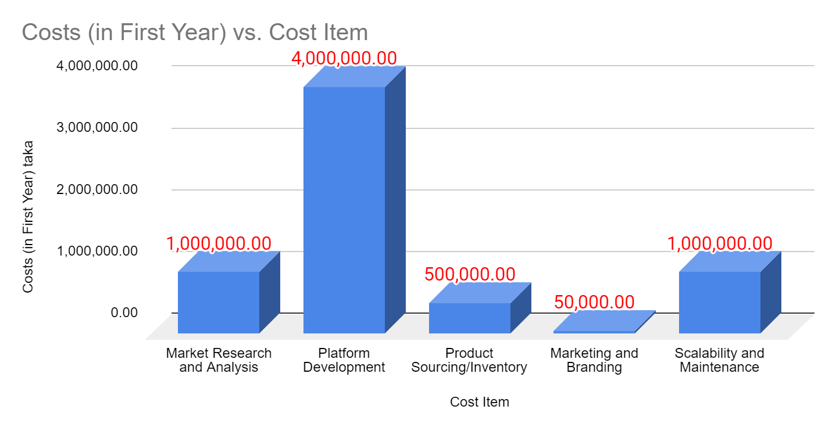

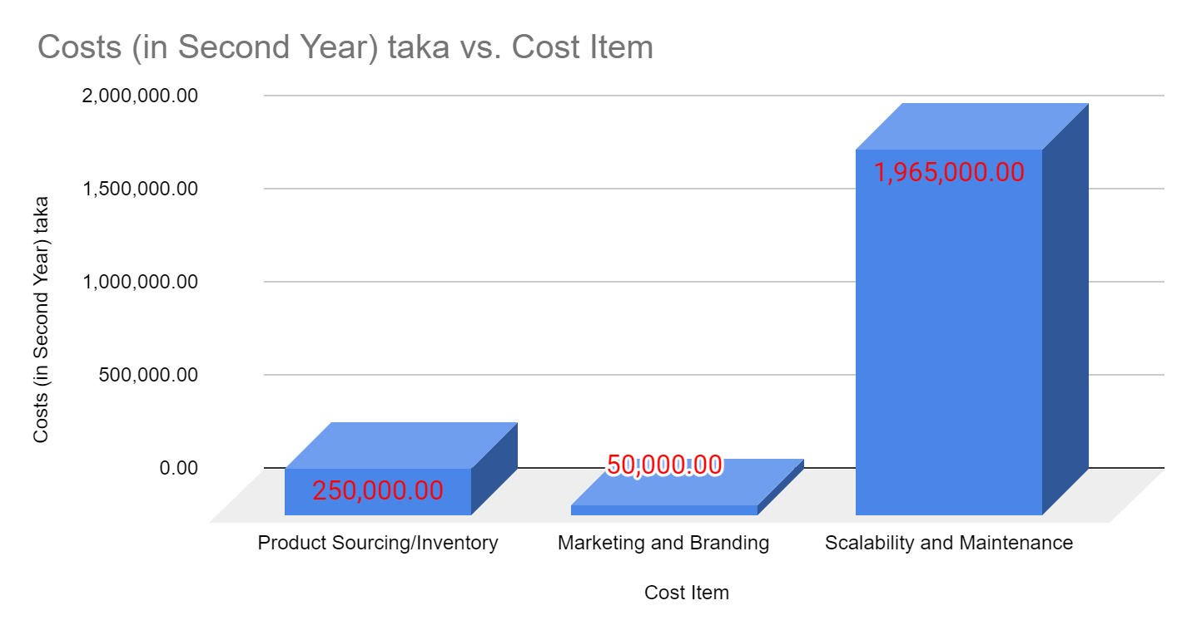

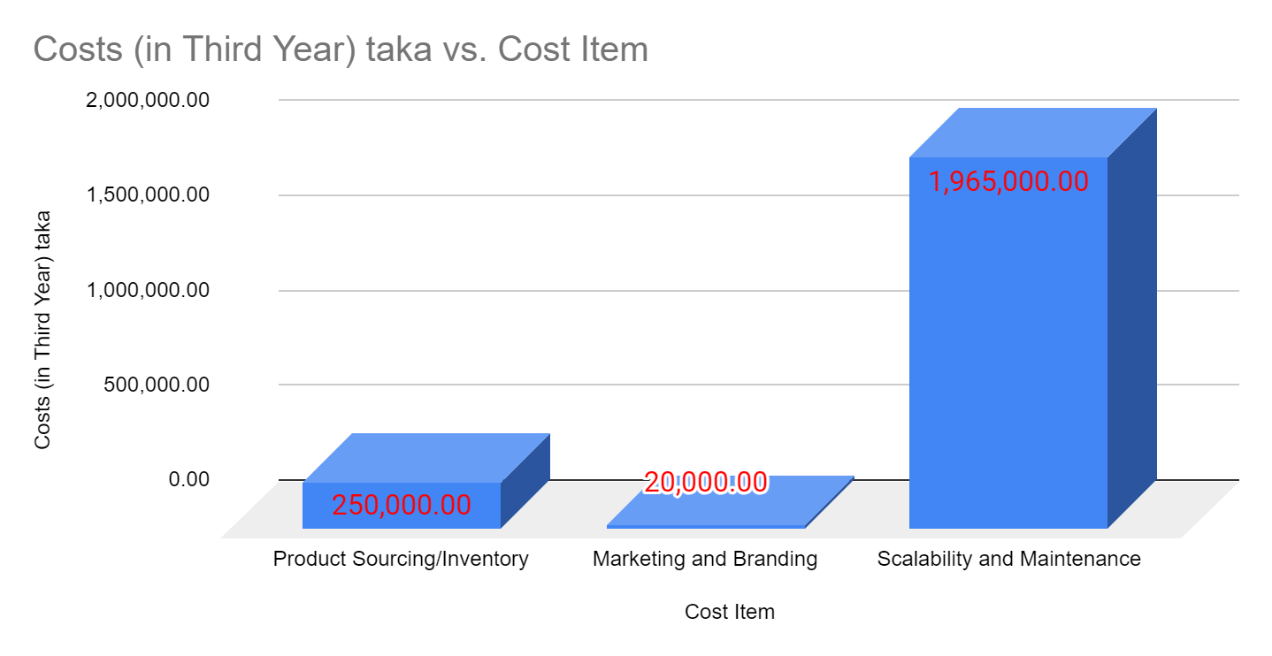

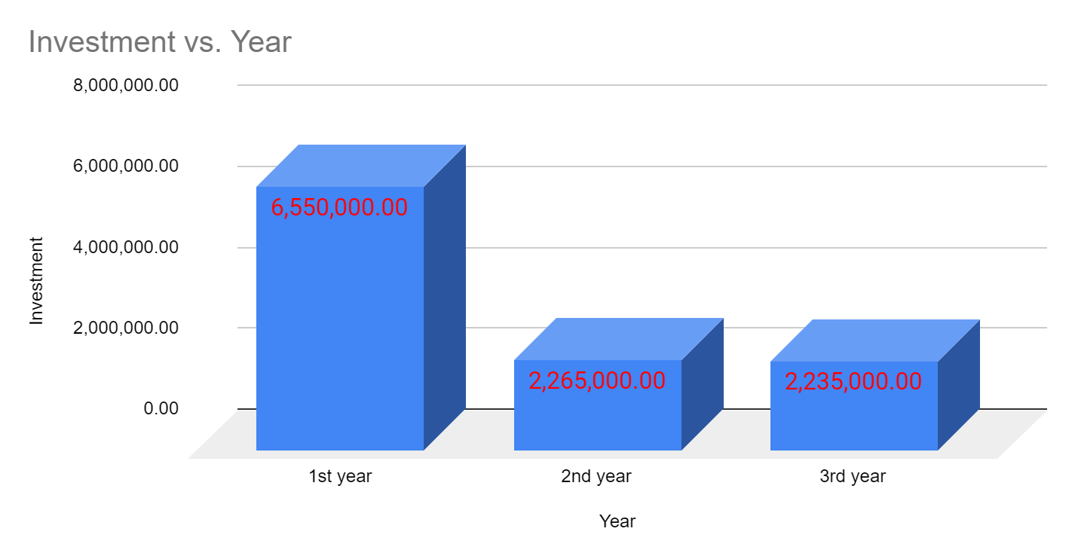

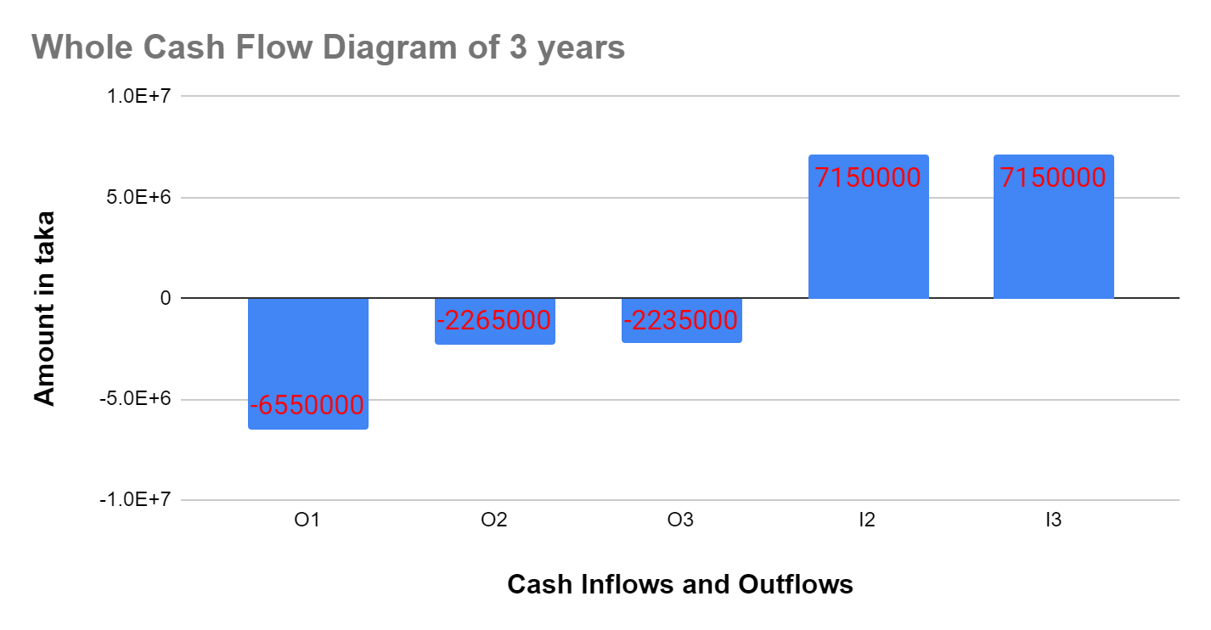

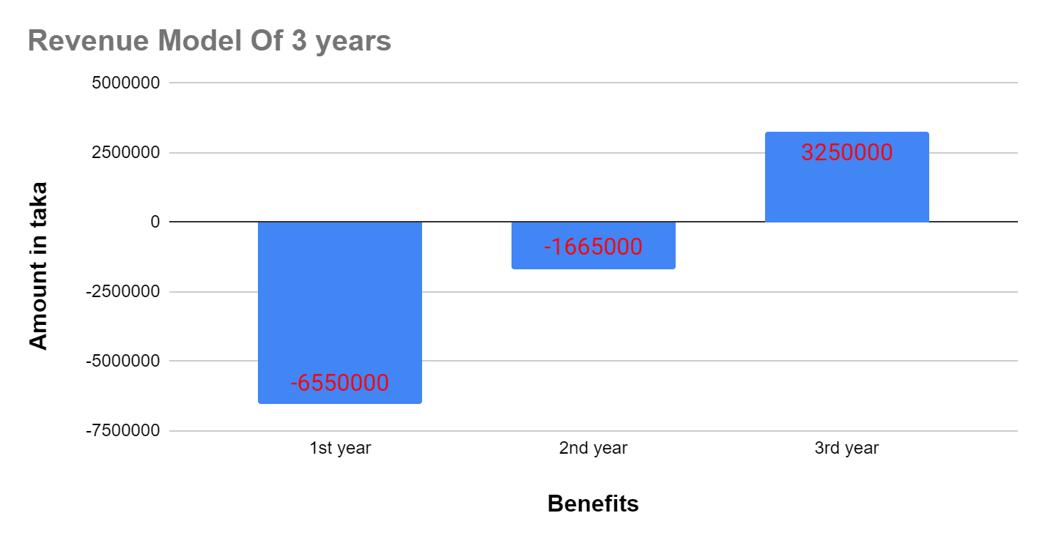

## **UML Diagram**

Software engineers use UML (Unified Modeling Language) diagrams as visual aids to show many facets of a system's behavior and structure. They are available in a variety of forms, such as behavioral diagrams like sequence diagrams that illustrate how objects interact over time, and structural diagrams like class diagrams that explain the relationships and static structure of classes. These diagrams facilitate stakeholder communication and software development processes by using standardized notations to represent features like classes, connections, and interactions. Software systems can be effectively specified, designed, and documented using the use of UML diagrams.

### **Use Case Diagram**

In UML (Unified Modeling Language), a use case diagram shows how users or other systems interact with a system to achieve particular objectives. By displaying the several use cases (actions or functions) that users can execute and how they connect to the players involved, it offers a high-level overview of the system's capabilities. Use Case Diagram has Four Elements:

* Actor
* Use cases
* Connections
* System

**Symbols of Use Case Diagram**

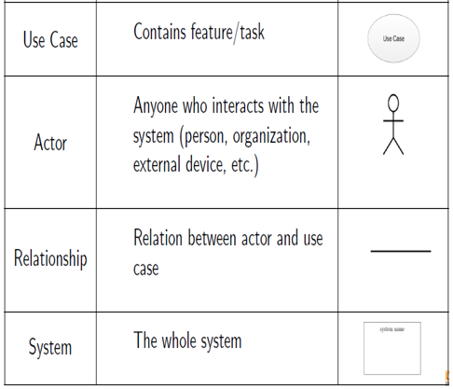

|  |
| --- |
| Include (mandatory execution relationship) |
| Extend (optional execution relationship) |

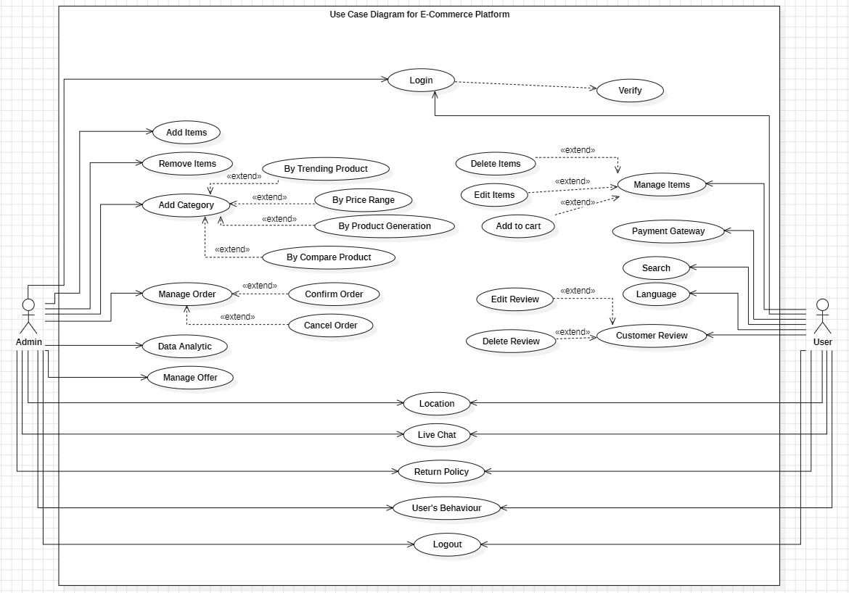

**Figure 3: Use Case Diagram for E-commerce Platform**

#### **Use Case Description**

Use case descriptions give thorough justifications of the procedures necessary to do particular activities inside a system. Extend (optional execution relationship).Elements of use case descriptive form are

Use case number and name

Primary Actor

Stakeholders and Interests

Preconditions

Success Scenario

Alternate Scenario

Post-conditions

Let's examine three typical use cases associated with e-commerce: Product Category, User Login, and Search Product.

**Product Category**

**Use Case Number and Name:** UC001 - Product Category  
**Primary Actor:** Registered User  
**Interests & Stakeholders:** Customers may quickly browse and locate products in particular categories.  
**Prerequisites:** The user has logged onto the online store.  
**Success Scenario:** The user accesses the category section or homepage. The product categories are listed on the system. The user decides on a certain interest category. The selected category's products are shown by the system. Within the chosen category, users have the option to browse or further filter products.  
**Alternative Scenario:** The user chooses a category in which there are no products: The chosen category is now empty, and the system indicates with a message.  
**Post-Condition:** The user explores and views products in the chosen category with success.

**Search Product**  
**Use Case Number and Name:** UC002 - Search Product  
**Primary Actor:** Logged in Individual  
**Interests & Stakeholders:** Customer: Easily locate goods according to preferences.  
**Prerequisites:** The user has an active session.  
**Success Scenario:** A search query is entered by the user. Relevant products are shown by the system.   
**Alternative Scenario:** No results found: System notifies the user and suggests alternative searches.  
**Post-Condition:** A list of pertinent products is displayed to the user.

**User Login**  
**Use Case Number and Name:** UC003-User Login  
**Primary Actor:** Visitor or Signed-in User  
**Interests & Stakeholders:** Customer: A safe and easy way to log in. Admin: Monitors user behavior for safety.  
**Prerequisites:** The user is signed in.  
**Success Scenario:** User inputs legitimate login information. The system authorizes access after confirming credentials.  
**Alternate scenario:** Invalid login information The system asks users to re-enter their login information.  
**Post-Condition:** The user has successfully logged into the system.

* 1. **Activity Diagram**  
     System processes are represented by rounded rectangles for activities and arrows for transitions in UML activity diagrams. They facilitate stakeholder communication and system knowledge by outlining the order of tasks, decision-making points, and concurrent activities.symbol of activity diagrams are

|  |
| --- |
| **Joining Nodes** |

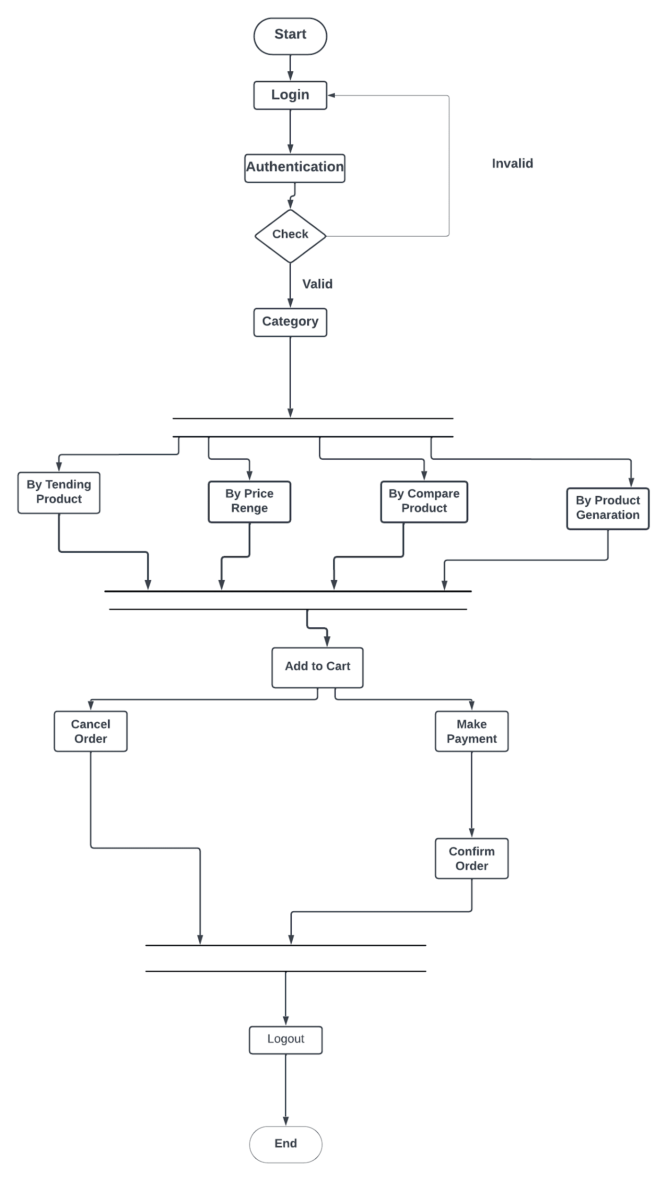

**Figure 4: Activity Diagram for Product Category**

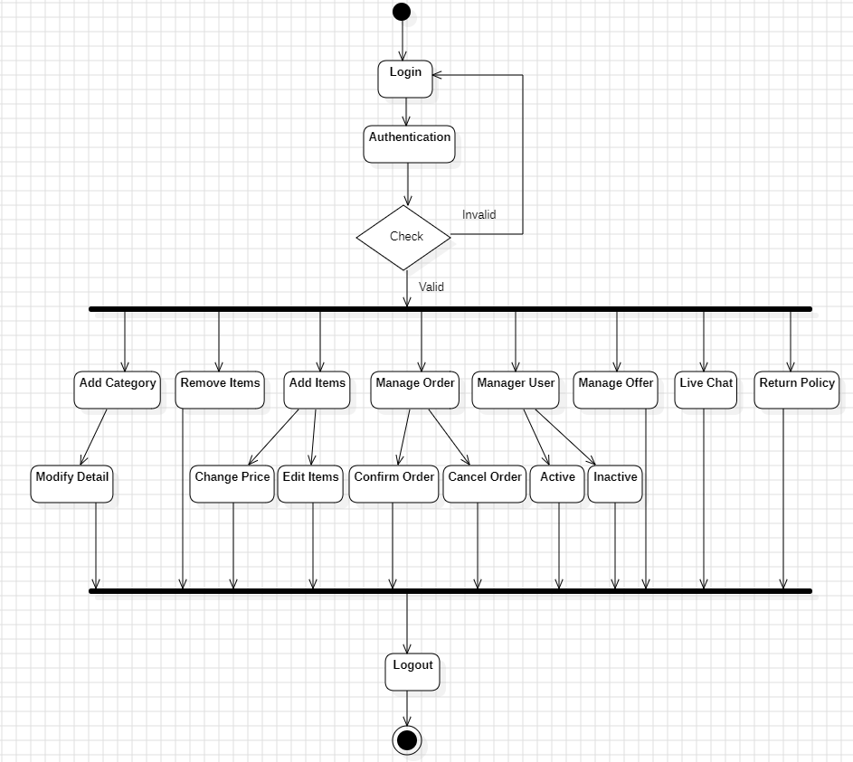

**Figure 5: Activity Diagram of Admin Side**

## **References**

1. Dospinescu, O., Dospinescu, N. and Bostan, I., 2022. Determinants of e-commerce satisfaction: A comparative study between Romania and Moldova. Kybernetes, 51(13), pp.1-17.

2. Dzulfikar, M.F., Purwandari, B., Sensuse, D.I., Lusa, J.S., Solichah, I., Prima, P. and Wilarso, I., 2018, May. Personalization features on business-to-consumer e-commerce: Review and future directions. In 2018 4th International Conference on Information Management (ICIM) (pp. 220-224). IEEE.

3. Taher, G., 2021. E-commerce: advantages and limitations. International Journal of Academic Research in Accounting Finance and Management Sciences, 11(1), pp.153-165.

4. Bhat, S.A., Kansana, K. and Khan, J.M., 2016. A review paper on e-commerce. Asian Journal of Technology & Management Resesarch [ISSN: 2249–0892], 6(1).

5. AbdAlameer,E.M.,2014. Building and developing E-commerce website. International Journal of Science and Research (IJSR), 3(9),1419-1425.

6. Jain, V.I.P.I.N., Malviya, B.I.N.D.O.O. and Arya, S.A.T.Y.E.N.D.R.A., 2021. An overview of electronic commerce (e-Commerce). Journal of Contemporary Issues in Business and Government, 27(3), 665-670.

7. <https://www.daraz.com.bd/>

8.<https://evaly.com.bd/>

9.<https://www.amazon.com/>

10.<https://www.rokomari.com/book>

11.<https://chaldal.com/>

12.<https://bikroy.com/>